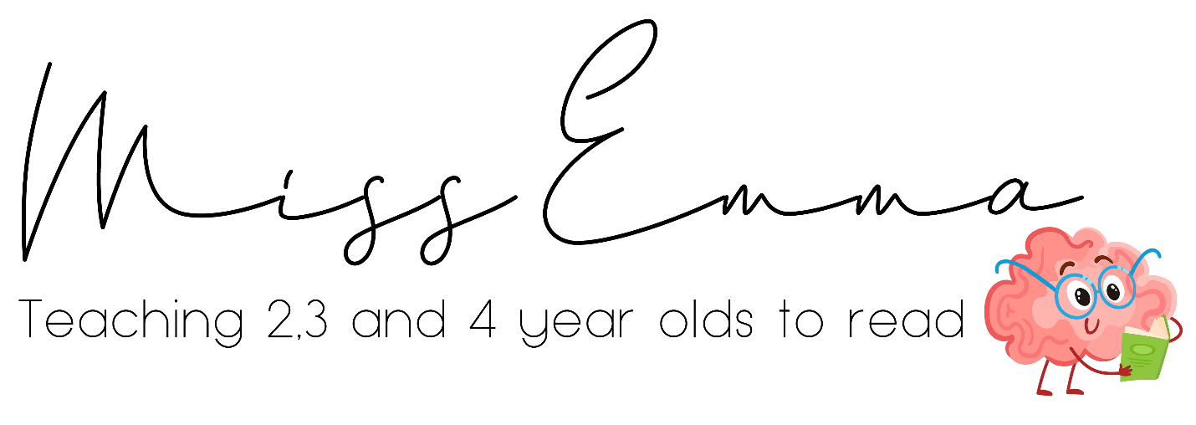
‘Reading Ready Brains’ Pilot Sessions for Parents of 3 and 4 Year Olds
– Sign Up Form
Info and Dates on ReadingReadyBrains.com
It will be quicker if you could please send a friends request to Facebook.com/emmalewis2017
Which group would you like to join? (dates)
Do you have the Monster Mapping Kit Handbook already?
When was this purchased?
AU$
https://www.speechsoundpics.com/product-page/monster-mapping-kit-handbook-a4
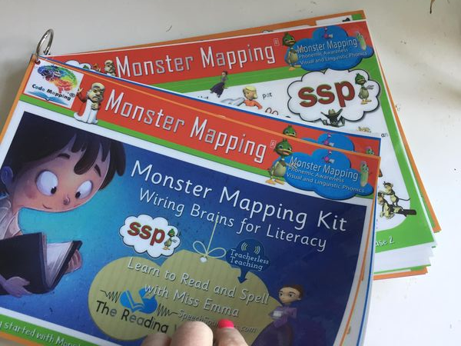
GB£
https://www.readingreadybrains.com/product-page/monster-mapping-kit-handbook-a4

Name of Parent/s or Carers of Participating Child/ Children :
Username on Facebook (you will be invited to the support group – use a newly created profile if you wish)
Is English your first language?
Email
Country
Name of Child/ Children
How do you pronounce their first name? If easier, record yourself saying
it and send via FB messenger
Date of Birth
Do you agree to provide regular updates to your child’s thread? These would be in the form of comments, images, videos…and as this is a private group no-one will see them, other than other parents.
If there are clips shared that would be useful for others, to understand the approach, you will be asked (privately) if Miss Emma can use them. She will show you what will be shared, before doing so.
Do you have any questions about this?

Do you have any questions? Anything you would like to share?

I understand that Miss Emma reserves the right to remove me from the pilot at any time (we put this in to cover anything unexpected – eg a ‘spy’ signs up to try to see what’s happening!)
Signed
Date
Please print, complete, scan and then email it to us
Support@TheReadingHut.com
